Source 1: Letters to R.B. Bennett during the Great Depression

A. Dear Sir,
Three little baby boys were born to Mr. and Mrs. Samuels in our vicinity.
Like many others they have had some very bad luck.
The parents are a very fine type, not the kind with the hand out for help.
We hope you will feel toward these unfortunate people the way we do.
Yours truly,
Elizabeth Ratray
Welsley Ont,
Sept. 27,1933

Dear Mr. and Mrs Samuels,
I am enclosing herewith a 20 dollar bill, which I trust may be of some little service to you during the Christmas season.
I learned the other day that one of the triplet boys had passed away and I extend to you my sincerest sympathy,
With best wishes, believe me I am
yours faithfully
Oct 13, 1933

B. Dear____________,
I believe you to be good as well as a great man
therefore I am appealing to you to save my home.
Picture yourself, through no fault of your own,
homeless with sons willing, but unable to provide for you.
Please help me or tell me what I can do.
Yours Sincerely and hopefully, Laura Bates.
Toronto Sept 3, 1933

Dear Madam,
I am certainly willing to help you and if you will be good enough to let me know what company holds the mortgage on your home I will look into the matter and see if anything can be done to straighten out your difficulties.
yours faithfully,

c. Dear Sir,
I am writing to see if their is any help I could get.
As I have a baby thirteen days old that only weighs
one pound and I have to keep in cotton Wool & Olive Oil,
and I haven’t the money to buy it, if their is any help I could get
their will be two votes for you next election
Hoping to hear from you soon
Yours Truly,
Mrs. Jack O’Hannen
Murray Harbour, PEI

Her letter to Bennett was Mrs. Jack O’Hannen’s last hope. When he received it, Bennett opened his wallet and sent the young mother five dollars - enough money to cover groceries for about a month.

Source 2: Political Cartoons

A. Manitoba Free Press, Winnipeg, 8 Apr 1930.
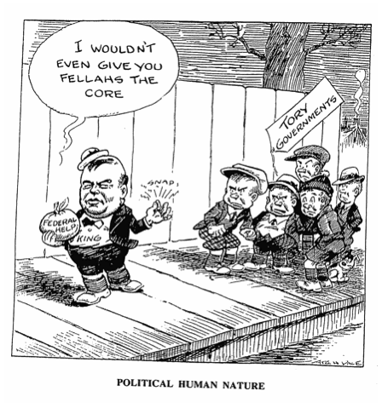

B. The Young Worker, Toronto, 6 Oct 1930.
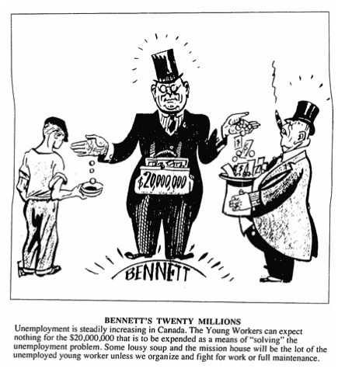

C. The Evening Telegram, Toronto, 11 Apr 1932.
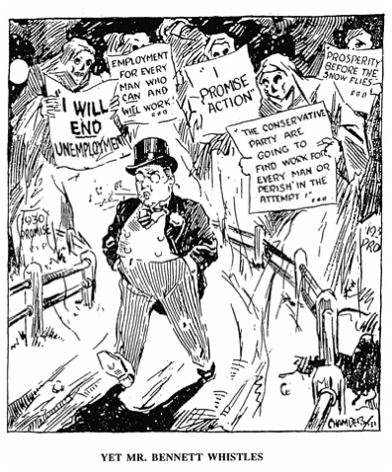
D.
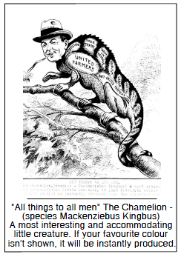

E.
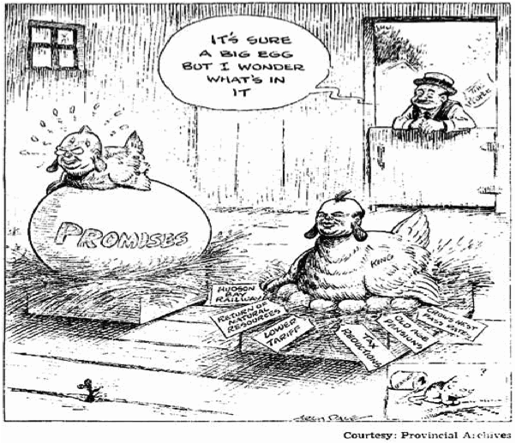

Source 3: Photos
A. “Bennett Buggy”
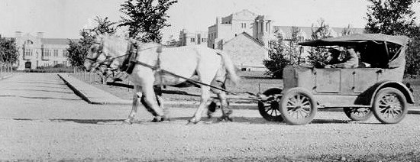

B. “Bennett Barnyard”
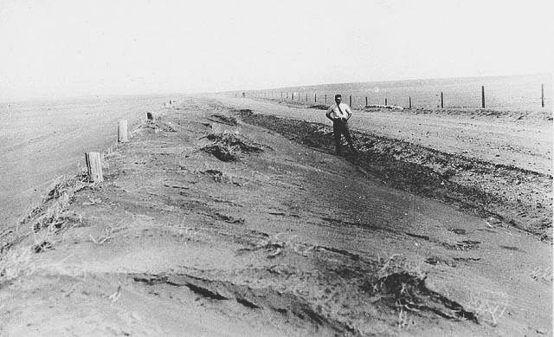

C. “Bennett Blankets”
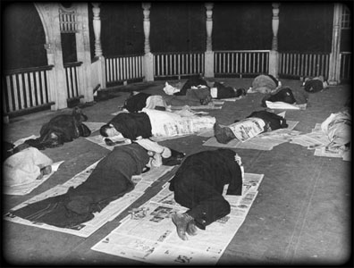

D. Jobless men
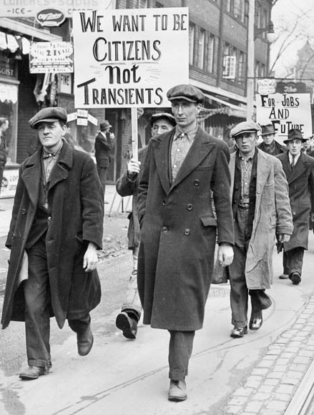

E.
